A4050-US-AL-Gorget-Whale Effigy-Huithliwalli site-Deptford|Weeden Is-Proto Mississippian- Vesicular Andesite-800 BCE-700 CE 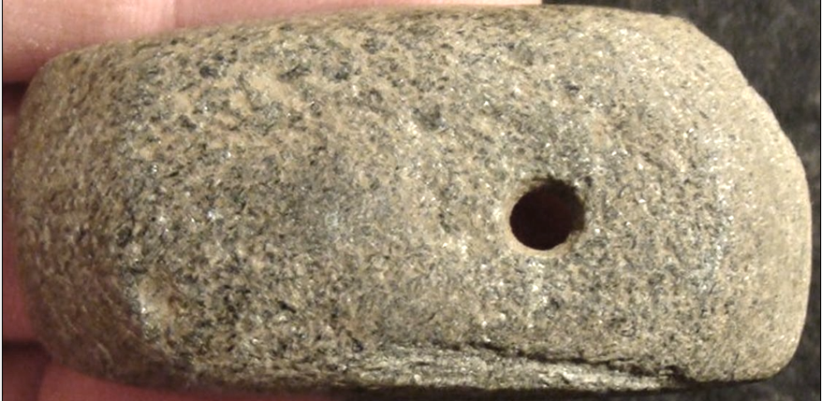 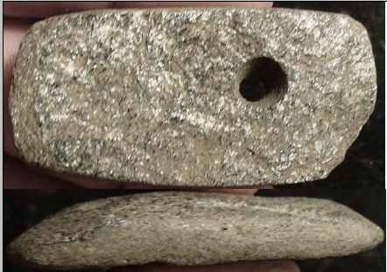

Figs 1-3. US-AL-Gorget-Whale Effigy-Huithliwalli site-Deptford|Weeden Is-Proto Missisippian- Vesicular Andesite-800 BCE-700 CE

Case no.: 12

Accession Number: A4050

Formal Label: US-AL-Gorget-Whale Effigy-Huithliwalli site-Deptford|Weeden Is-Proto Mississippian- Vesicular Andesite-800 BCE-700 CE

**Display Description:**

The upper Choctawhatchee River valley in southeastern Alabama encompasses undefined Weeden Island culture variants such as reflected in the Huithliwalli site which has produced many sea-shell necklaces. This may be a remnant of the Deptford culture (800 BCE—700 CE) which was coastally oriented. These people may have engaged in whale hunting or, more probably, scavenged beached whales after storms in the Gulf of Mexico. This activity would have accounted for the present gorget, which is an artist’s provocative and very simple yet effective portrait of the spirit of a whale when alive: the eyes are drilled wide-open and the mouth is partially open as in life. In either case this is a remarkable and unique find by Dr. Burke. The Deptford culture was characterized by an increasing religious hierarchy reflected in the development of elaborate ceremonial areas, which were ostensibly made possible by incipient agriculture. A developing dichotomy between the sacred and the secular is reflected in artifacts such as this gorget, which is not a physical, secular whale but its sacred and spiritual manifestation, invoking it when it was alive. This dichotomy of the sacred and the secular continued in the Weeden Island culture where it is expressed most powerfully in its ceramics (Milanich 2002).

**LC Classification: E99.W84**

Date or Time Horizon: (800 BCE—700 CE)

Geographical Area: eastern Alabama

**Illustration:**

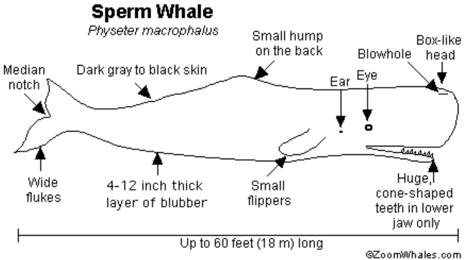

**GPS coordinates:**

Cultural Affiliation: Deptford-Weeden Island Cultures

Medium: vesicular andesite

Dimensions: H 1 1/8 in; W 2 1/8 in

Weight:

Condition:

Provenance: Ex Dr. Burke

**Discussion:**

**References:**

Milanich, Jerald T. (2002). "Weeden Island Cultures". In Anderson, David G.; Mainfort, Robert C., Jr. *The Woodland Southeast*. Tuscaloosa, Alabama: University of Alabama Press. pp. 352–372.